Year 5 Computing: Searching the Internet
Task: Find the answers the following questions using Google. Then complete the missing keywords in the middles using the correct letters.
Which flag does this country belong too?  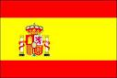 | What is the fastest animal in the world? | What is the capital of Australia?
How many sides does a heptagon? | Reveal the keywords using the yellow boxes | What is the capital of Italy?  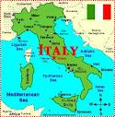
What is the capital of Spain?  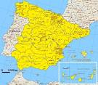 | How many legs does a spider have? | Where are the pyramids?  