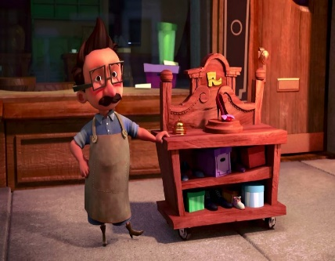
Can I create a character description?
Can you create a character description of the Little Shoemaker based on what you learnt from the film?

________________________________________________________________________________________________________________________________________________________________________________________________________________________________________________________________________________________________________________________________________________________________________________________________________________________________________________________________________________________________________________________________________________________________________________________________
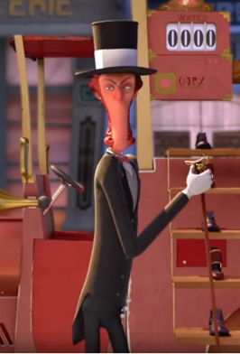
Can you create a character description of the Shoe Seller based on what you learnt from the film?

________________________________________________________________________________________________________________________________________________________________________________________________________________________________________________________________________________________________________________________________________________________________________________________________________________________________________________________________________________________________________________________________________________________________________________________________________________________________________________________________________________________________________________________________

