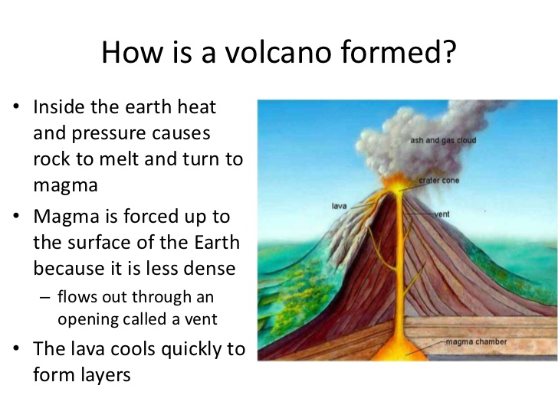
Inside the earth heat and pressure causes rock to melt and turn into _________. Magma is forced up from the magma __________ through the _______ _______to the earth’s __________ where it erupts. This happens through the ________ _________. When magma has erupted it has a new name called __________. In the sky there is an _______ _________.

Use this word bank to help you with the passage above:
magma crater cone ash cloud rock crust main vent lava chamber

